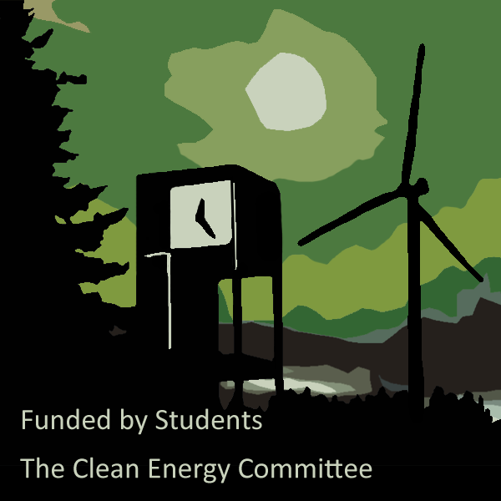**The Clean Energy Fund Grants**

Call for Applications – 2014/15

**1. The Clean Energy Fund Grant (CEFG) Description**

The mission of the committee is to support the success of energy efficiency, renewable energy, and resource conservation at Evergreen. We carry the responsibility of representing the interest of the student body as we appropriate the Clean Energy Fund. The fund is designated to offset 100% of the electricity used by Evergreen through renewable energy credits. The committee allocates the remaining fund to students, staff and faculty with goals of reducing the campus carbon footprint through research, education, or implementation. The Clean Energy Committee supports the creation of models for climate solutions through collaborative on-campus research.

The Clean Energy Committee (CEC) was created in 2005, after students voted in favor of the Clean Energy Initiative, a self-imposed student fee of $1 per credit. The original fee structure used 90% of the funds to purchase renewable energy credits (RECs) to offset 100% of the college’s electricity use; the remaining 10% established the Clean Energy Fund (CEF). As the price of RECs and the college’s energy use both fell, the CEF grew and has evolved to support a diverse array of student, staff and faculty led renewable energy, resource conservation and sustainability projects. The CEFG makes those funds available to support on-campus clean energy, resource conservation and sustainability projects.

Applications must be received by **5:00pm** on the day of the deadline.

**2. Eligibility Requirements and Project Restrictions**

Current students, faculty, and staff of The Evergreen State College, may apply for grant funds. Students must be enrolled and on campus regularly for the expected duration of their proposed project. A department, official campus organization, program, or group made up of a mix of students, staff and faculty may apply. The application must be submitted by an individual, who will be responsible for reporting on progress for projects that are funded by the CEC. All projects require at least one faculty or student activities advisor for sponsorship.

Projects eligible for funding must fall into one of the following categories:

1. Research into renewable energy and conservation technologies that will contribute to advancement of sustainability practices and academics on campus
2. Implementation of projects intended to save energy, produce electricity or conserve resources
3. Demonstration and education projects that share sustainability strategies with the campus community

Awarded funds can be used for labor, materials, and supplies to achieve the project goals. Preference will be given to grant requests for materials, supplies and workshop opportunities. Travel expenses will be awarded if the grantee presents a unique learning opportunity and further plans to enrich the campus community through educational outreach. The grantees will work with the committee coordinator and project director, who are available to aid in problem solving.

The grantee is expected to communicate with the CEC project director about their project at least once monthly. The grantee is also required to provide a formal update to the CEC in the spring of 2015. Additionally, the grantee must design a poster and/or presentation to be included at the Clean Energy Fair and/or Science Carnival.

Projects must be initiated in a timely manner and completed during the 2014-2015 academic year. Any funds not expended by June 5th, 2015 will return to CEC. **Applicants must also visit the CEC office hours or schedule an appointment to preliminarily review the proposal and receive advice from a student committee member.**

Questions regarding the CEFG application process may be directed to the committee coordinator at [cleanenergy@evergreen.edu](mailto:cleanenergy@evergreen.edu?subject=CEFG%20grant%20questions).

**3. Criteria for Selection**

Grant awardees should demonstrate the following:

* Alignment with the Clean Energy mission and vision
* Potential to achieve green results
* Relevant work or volunteer experience
* Cost effective use of funds
* Measurable benefit
* Project longevity
* Creativity
* Engagement with the Evergreen community
* Education and outreach

**4. Application Requirements and Deadlines**

Applications must be received by **5:00pm the day of the deadline.** All materials must be submitted in digital format, to [**cleanenergy@evergreen.edu**](mailto:cleanenergy@evergreen.edu?subject=Clean%20Energy%20Fund%20Grant)**.** As detailed below, you must include a complete application containing **personal information, a** **detailed budget, proposed metrics, a detailed schedule/timeline, reference(s), continuity assessment, a resume** **or curriculum vitae, and a project description**. Put "Clean Energy Fund Grant" in the subject line. You will receive an email confirmation of receipt of your application. If necessary, you may attach references, diagrams or illustrations as supplemental materials. Before the proposal review session, applicants must visit the committee office hours and review their proposal with a student member.

**LATE OR INCOMPLETE APPLICATIONS WILL NOT BE CONSIDERED**

**Remember to visit CEC office hours before the proposal review meeting. This will help complete the application**

***A. Student Applicants***

Please include in sidebar of application

*Personal Information*

1. First and last name
2. A number
3. Phone number ( please specify whether home, work or mobile)
4. E-mail address
5. Student group or program
6. Class standing: Undergraduate/Graduate (graduate students please indicate MES, MPA, MIT)
7. Expected graduation date
8. Emphasis
9. Faculty sponsor name and e-mail
10. Other participants

*Reference Information*

*(Please include reference information with Resume or Curriculum Vitae)*

Please include the following information for 1 or 2 individuals who can attest to your abilities and interest in resource conservation, environmental sustainability and renewable energy. At least one reference must be a faculty or staff member at Evergreen. Off-campus supervisors, and resident assistants may be included as second references. If you plan to work with a department on campus, a reference from the individual with whom you plan to work is required.

1. Name of Reference
2. Title
3. Phone number (please specify whether home, work, or mobile)
4. E-mail address
5. One sentence description of your relationship with reference

(e.g. professor for a program you took, supervisor for an on campus job)

***B. Faculty and Staff Applicants***

Please include in sidebar of application

*Personal Information*

1. First and last name
2. A Number
3. Phone number (please specify whether home, work, or mobile)
4. E-mail address
5. Department
6. Expertise
7. Other participants

*Reference Information*

*(Please include reference information with Resume or Curriculum Vitae)*

Please include the name of 1 or 2 co-workers, supervisor, or faculty members with whom you have worked or who can attest to your abilities and interest in resource conservation, environmental sustainability and renewable energy. If you plan to work with a department on campus a reference from the individual with whom you plan to work is required.

1. Name of Reference
2. Title
3. Phone number
4. Email address
5. One sentence description of your relationship with reference

(e.g. supervisor, co-worker on a project)

***C. All applicants***

*Project Description:* Provide a brief description of the project on the application. Please include goals, rationale, and expected results.

*Detailed Timeline:* Please include a timeline on the application. Include monthly or quarterly targets, as appropriate. Include update to the CEC in spring 2015 and creation of poster and/or presentation for the Clean Energy Fair or Science Carnival in spring 2015.

*Project Metrics****:*** Describe in the application how the project will meet expected results and how project effectiveness will be measured (i.e. resources saved, students educated, etc.). Degree of metric rigor should be commensurate with level of funding requested.

*Campus Approval:* Does your project require any approvals from campus departments for implementation of this project? Have you obtained these approvals? If so, please identify who you have received approval from. If additional approvals are still required, please identify the groups (departments, committees, etc.) that will need to approve the implementation of the project. Grant proposals must have the appropriate departmental sponsorship of areas on campus that may be affected. Applicants of proposals involving installations on campus are encouraged to consult with Facilities prior to submitting their proposal to ensure the proper support. The following examples are common with Clean Energy proposals:

* + Permanent installations on all campus land are subject to approval of the [Campus Land Use Committee](http://www.evergreen.edu/committee/cluc/applications.htm) (CLUC).
  + The Associate Vice President for Academic Budget and Financial Planning must approve all academic proposals (faculty or students requiring a faculty sponsor).
  + Projects on the farm require the approval of the Organic Farm Manager.
  + Any lab-based research requires the approval of the Science Operations Manager.
  + All projects located in housing will require the approval of Assistant Director of Residential Facilities.
  + If there are any safety concerns, the Environmental Health and Safety Officer must be consulted.

*Sustainability:* On page two of the application, discuss the relationship of this project to the larger sustainability initiatives across campus. Be sure to include how your project aligns with the Climate Action Plan or the goal of zero waste and carbon neutrality by 2020? And, how your project is consistent with the mission of the CEC?

*Continuity:* On page two of the application, discuss the long-term implications of your project. Including, maintenance, operational costs, end of life disposal…

*Detailed Budget:* One-page. Excel spreadsheet format preferred. Provide enough narrative detail for a reviewer to understand the major costs of the project and assess if the requested award is reasonable and necessary. Please include other funding (including any in-kind contributions) that you will leverage with a CEF grant.

*Resume or Curriculum Vitae:* Include relevant work, research, and volunteer experience.